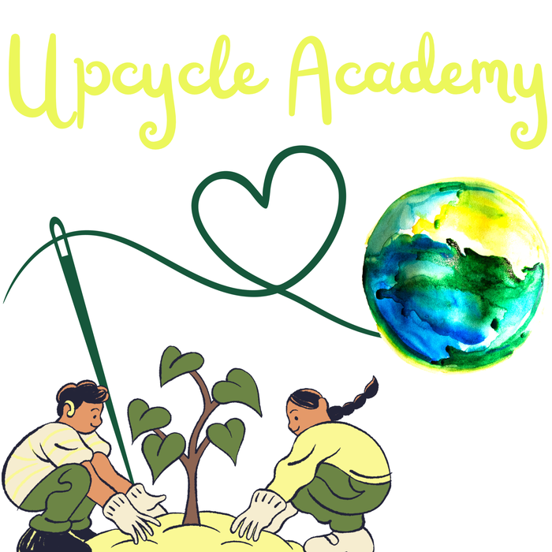 | Welcome to our workshop  Collection, sorting and textile upcycling: giving materials a second life
Getting started with your visit  At Upcycle Academy (La Gaude), a team of three to four, one or two drivers and two sorting and quality-control operators, collects, sorts and transforms textiles into new creations. Take your time to explore; we are happy to guide you.  - Welcome desk: introduce yourself to the team and let us know the purpose of your visit.  - Workshop areas: bag reception (QR code scan), weighing and sorting, cutting, sewing, finishing and display space.  - Moving around: follow the clear walkways and stay accompanied in working areas.  - Reception and sorting areas: reserved for the team; visitors stay behind the floor markings.  - Questions: please ask before touching or using any tool.  - Photos: kindly ask for people's consent before photographing them. |  | Essential safety rules  - Closed-toe shoes required; tie back long hair and avoid loose clothing near machines.  - Sharp tools: handle scissors, cutters and pins with care and never leave them on the floor.  - Machines and iron: use only with the team's permission; hot surfaces, do not touch.  - Clear walkways: no bags, big bags or fabric scraps in aisles or in front of exits, including around the van loading area.  - Food and drinks: only in the designated area, never near machines or fabrics.  - Children: must be supervised by an adult at all times.  - In case of alarm: stay calm, follow the team's instructions and head to the nearest emergency exit.

Emergency: 112 • Fire brigade: 18 • Medical emergency: 15 | Extinguisher, first-aid kit and emergency exit: see plan displayed at the entrance
Thank you for visiting Upcycle Academy, and enjoy your discovery!

